Steps to Setting up Open5GS
Install Ubuntu ver 22.04 in VMWare/Dual Boot
Refer to this 2 link to setup
https://open5gs.org/open5gs/docs/tutorial/01-your-first-lte/
https://nickvsnetworking.com/my-first-5g-core-open5gs-and-ueransim/

# IMPORTANT
Install gcc 11 and g++ 11 first if not the UERANSIM will not work
CC=gcc-11 CXX=g++11 cmake ../

# Setting up MongoDB
sudo apt update
sudo apt install gnupg
curl -fsSL https://pgp.mongodb.com/server-8.0.asc | sudo gpg -o /usr/share/keyrings/mongodb-server-8.0.gpg --dearmor

echo "deb [ arch=amd64,arm64 signed-by=/usr/share/keyrings/mongodb-server-8.0.gpg] https://repo.mongodb.org/apt/ubuntu jammy/mongodb-org/8.0 multiverse" | sudo tee /etc/apt/sources.list.d/mongodb-org-8.0.list

# Install MongoDB
sudo apt update
sudo apt install -y mongodb-org
sudo systemctl start mongod (if '/usr/bin/mongod' is not running)
sudo systemctl enable mongod (ensure to automatically start it on system boot)

# Install Open5GS
sudo add-apt-repository ppa:open5gs/latest
sudo apt update
sudo apt install open5gs

# Install WebUI of Open5GS
# Download and import the Nodesource GPG key
sudo apt update
sudo apt install -y ca-certificates curl gnupg
sudo mkdir -p /etc/apt/keyrings
curl -fsSL https://deb.nodesource.com/gpgkey/nodesource-repo.gpg.key | sudo gpg --dearmor -o /etc/apt/keyrings/nodesource.gpg

# Create deb repository
NODE_MAJOR=20
echo "deb [signed-by=/etc/apt/keyrings/nodesource.gpg] https://deb.nodesource.com/node_$NODE_MAJOR.x nodistro main" | sudo tee /etc/apt/sources.list.d/nodesource.list

# Run Update and Install
sudo apt update
sudo apt install nodejs -y
curl -fsSL https://open5gs.org/open5gs/assets/webui/install | sudo -E bash –

Follow this configuration
/etc/open5gs/nrf.yaml
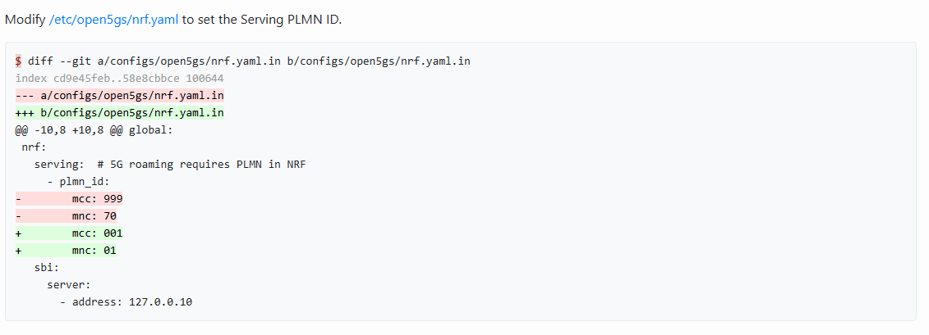

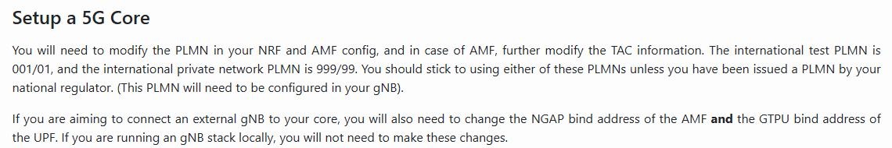/etc/open5gs/amf.yaml [Take note of the IP addresses, if running on same device]
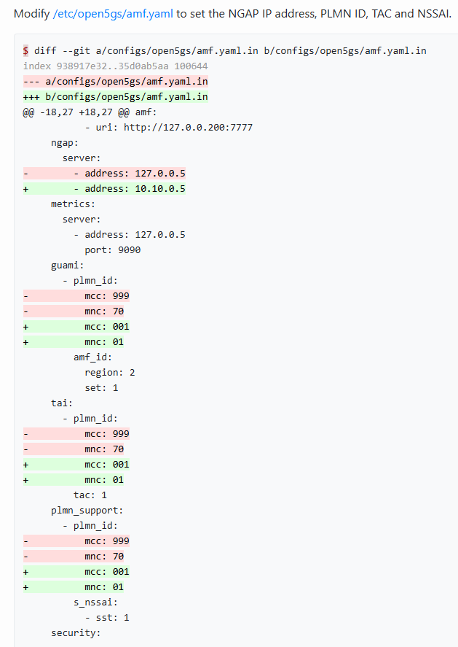

/etc/open5gs/upf.yaml
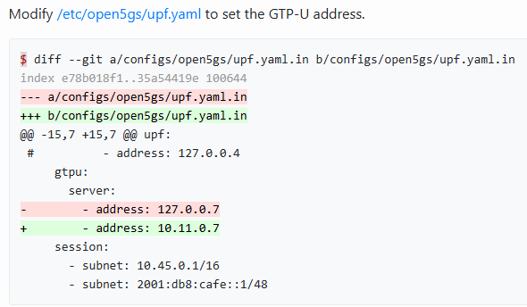
# Restart Open5GS services
sudo systemctl restart open5gs-nrfd
sudo systemctl restart open5gs-amfd
sudo systemctl restart open5gs-upfd

# Register Subscriber to Open5GS
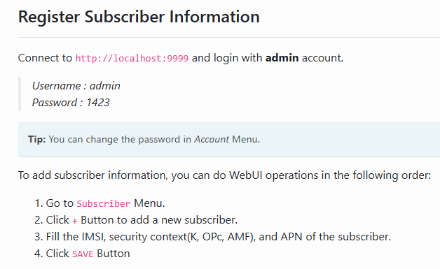
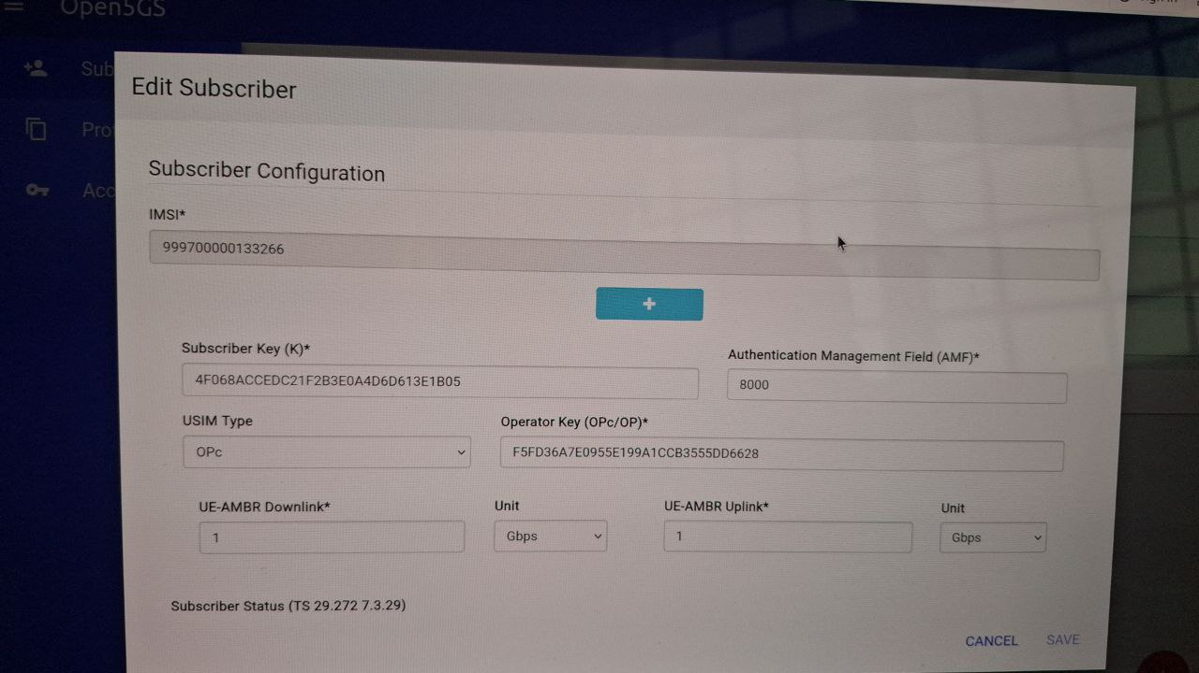
IMSI: 999700000133266
K: 4F068ACCEDC21F2B3E0A4D6D613E1805
OPc: F5FD036A7E0955E199A1CCB3555DD6628
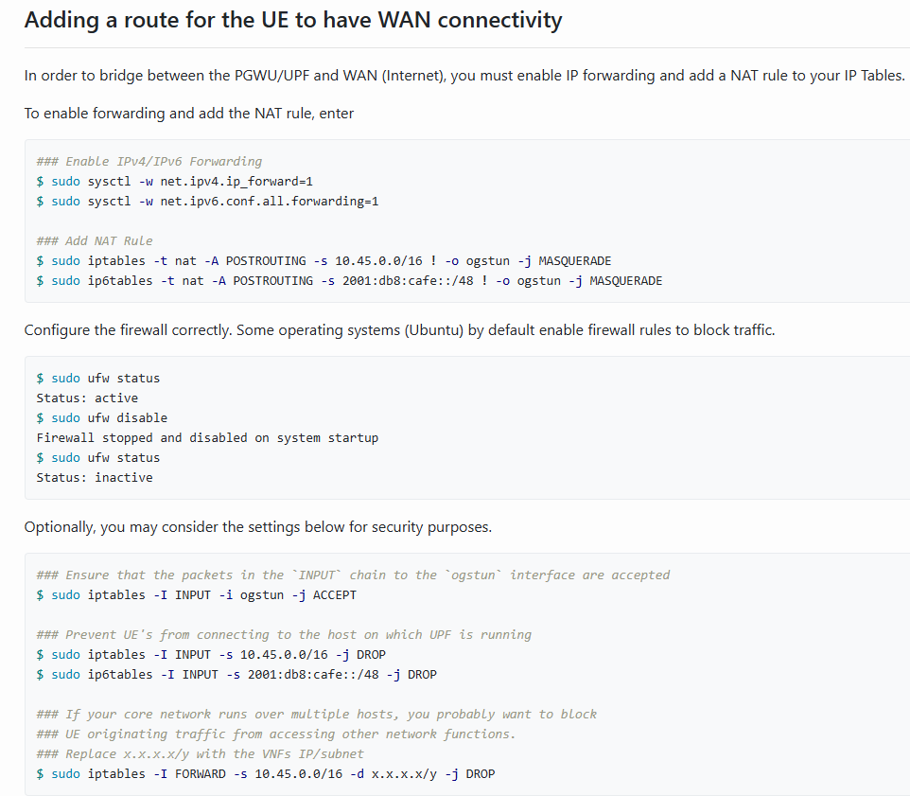

Setting up UERANSIM
sudo apt update
sudo apt upgrade
sudo apt install make g++ libsctp-dev lksctp-tools
iproute2 sudo snap install cmake –classic
git clone https://github.com/aligungr/UERANSIM
cd UERANSIM
make
make necessary configuration to UERANSIM/config folders

# Steps to start UERANSIM simulation
In the UERANSIM folder:
Start up gNodeB
build/nr-gnb -c config/open5gs-gnb.yaml
Connects UE
Build/nr-ue -c config/open5gs-ue.yaml

